Network Layer :
Network Layer is the third layer from the bottom (Layer 3) and the fifth layer from the top in the OSI (Open Systems Interconnection) Model. It is responsible for ensuring end-to-end packet delivery across multiple interconnected networks.
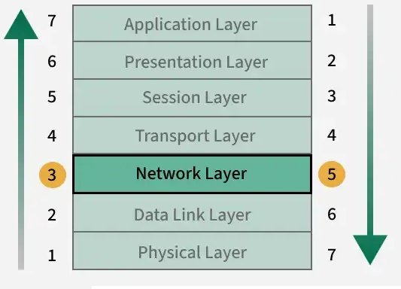

Key Responsibilities of the Network Layer

Logical Addressing
Packetization
Host-to-Host Delivery
Forwarding
Routing
Fragmentation and Reassembly
Subnetting
Network Address Translation (NAT)

Logical Addressing: Assigns unique IP addresses to devices, ensuring accurate identification and communication across networks.
Packetization: Encapsulates transport layer segments into packets for efficient transmission.
Host-to-Host Delivery: Ensures reliable delivery of packets from the sender to the intended receiver across diverse networks.
Forwarding: Moves packets from the input interface of a router to the appropriate output interface based on the destination IP.
Routing: Determines the optimal path for packets to travel across multiple networks using routing algorithms and protocols.
Fragmentation and Reassembly: Splits large packets into smaller fragments to match the maximum transmission unit (MTU) of a network, and reassembles them at the destination.
Subnetting: Divides larger networks into smaller subnetworks for efficient addressing and traffic management.
Network Address Translation (NAT): Maps private IPs to public IPs for internet communication, conserving address space and adding security.
Read more about Functions of Network Layer.
+++++
How the Network Layer Works
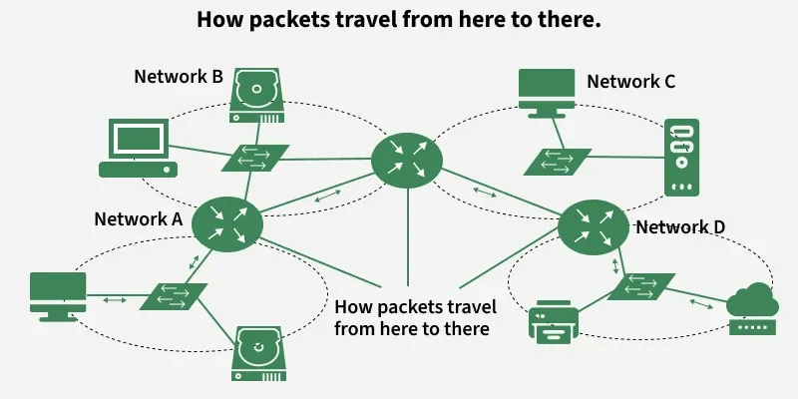

Each device is assigned a unique logical address (IP address).
Data from the transport layer is encapsulated into packets, with source and destination IPs attached.
Routers analyze the destination address and determine the best available path.
Packets traverse the network hop-by-hop, moving across routers until reaching the destination.
If the packet size exceeds the MTU(Maximum Transmission Unit), it is fragmented into smaller units.
At the destination, the fragments are reassembled into the original data.
If errors occur (e.g., unreachable destination), protocols like ICMP send error messages back to the source.
Protocols Operating at the Network Layer
IP (Internet Protocol – IPv4/IPv6)
ICMP (Internet Control Message Protocol)
ARP (Address Resolution Protocol)
RARP (Reverse Address Resolution Protocol)
NAT (Network Address Translation)
IPSec (Internet Protocol Security)
MPLS (Multiprotocol Label Switching)
Routing Protocols
RIP (Routing Information Protocol)
OSPF (Open Shortest Path First)
BGP (Border Gateway Protocol)
Advantages of the Network Layer
Enables end-to-end communication across multiple networks.
Supports scalability by allowing subnetting and hierarchical addressing.
Efficiently routes packets using shortest-path and dynamic routing algorithms.
Provides inter-networking by connecting heterogeneous networks.
Limitations of the Network Layer
No flow control mechanism; congestion may occur if too many datagrams are in transit.
Limited error control; mainly relies on upper layers for reliability.
Routers may drop packets under heavy load, leading to possible data loss.
Fragmentation increases processing overhead and may affect performance.

Network Layer Design Issues

The network layer comes with some design issues that are described as follows:
1. Store and Forward packet switching
2. Services provided to the Transport Layer
3. Implementation of Connectionless Service
4. Implementation of Connection oriented Service

1. Store and Forward packet switching
The host sends the packet to the nearest router. This packet is stored there until it has fully arrived once the link is fully processed by verifying the checksum then it is forwarded to the next router till it reaches the destination. This mechanism is called "Store and Forward packet switching."

2. Services provided to the Transport Layer
Through the network/transport layer interface, the network layer transfers its patterns services to the transport layer. These services are described below. But before providing these services to the transfer layer, the following goals must be kept in mind:-

Offering services must not depend on router technology.
The transport layer needs to be protected from the type, number, and topology of the available router.
The network addresses for the transport layer should use uniform numbering patterns, also at LAN and WAN connections.
Based on the connections there are 2 types of services provided :

Connectionless - The routing and insertion of packets into the subnet are done individually. No added setup is required.
Connection-Oriented - Subnet must offer reliable service and all the packets must be transmitted over a single route.
3. Implementation of Connectionless Service
Packets are termed as "datagrams" and corresponding subnets as "datagram subnets". When the message size that has to be transmitted is 4 times the size of the packet, then the network layer divides into 4 packets and transmits each packet to the router via. a few protocols. Each data packet has a destination address and is routed independently irrespective of the packets.

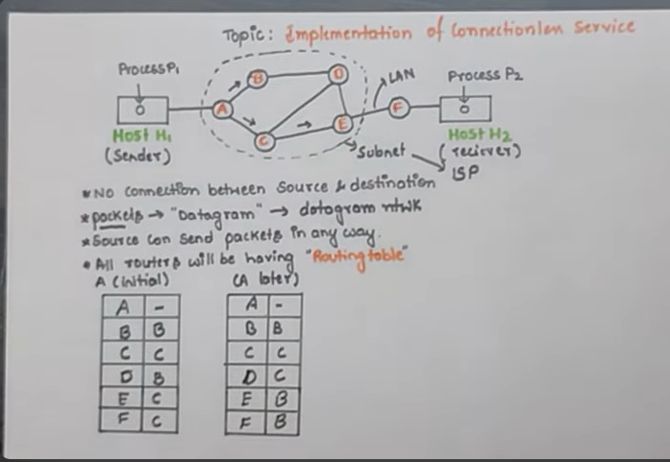
4. Implementation of Connection-Oriented service:
To use a connection-oriented service, first, we establish a connection, use it, and then release it. In connection-oriented services, the data packets are delivered to the receiver in the same order in which they have been sent by the sender. It can be done in either two ways :

Circuit Switched Connection - A dedicated physical path or a circuit is established between the communicating nodes and then the data stream is transferred.
Virtual Circuit Switched Connection - The data stream is transferred over a packet switched network, in such a way that it seems to the user that there is a dedicated path from the sender to the receiver. A virtual path is established here. While, other connections may also be using the same path.

